1. The Pearson Correlation Coefficient

Correlation

In statistics, the word "correlation" has a very specific meaning. Statistical correlation means that, given two variables X and Y measured for each case in a sample, variation in X corresponds (or does not correspond) to variation in Y, and vice versa. That is, extreme values of X are associated with extreme values of Y, and less extreme X values with less extreme Y values. The correlation coefficient (Pearson r) measures the degree of this correspondence.

Correlation and causation

If one variable causally influences a second variable, then we would expect a strong correlation between them. However, a strong correlation could also mean, for example, that they are both causally influenced by a third variable. Therefore a strong observed correlation can suggest a causal connection, but it doesn't per se indicate the direction or nature of that causation.

X → Y | X ← Y | X ↔ Y | X ← A → Y
X influences Y | Y influences X | X and Y influence each other | A influences X and Y

Alternative Explanations for Strong Observed Correlation

Important: Correlation between two variables does not prove X causes Y or Y causes X.
Example: There is a statistical correlation between the temperature of sidewalks in New York City and the number of infants born there on any given day.

Pearson r

There is a simple and straightforward way to measure correlation between two variables. It is called the Pearson correlation coefficient (r) – named after Karl Pearson who invented it. It's longer name, the Pearson product-moment correlation, is sometimes used.

The formula for computing the Pearson r is as follows:

$$r=\frac{1}{n−1}\sum{\frac{(x_{i}−\overline{X})(y_{i}−\overline{Y})}{s_{x}s_{y}}}$$

The value of r ranges between +1 and -1:

- r > 0 indicates a positive relationship of X and Y: as one gets larger, the other gets larger.
- r < 0 indicates a negative relationship: as one gets larger, the other gets smaller.
- r = 0 indicates no relationship

Let's intuitively consider how this formula works. It starts by subtracting the means from X and Y, and then multiplying the results. When we subtract the mean from a variable, some of the resulting values will be positive and some negative. When we subtract the means from both X and Y, that will happen with both variables.

If there is no association between X and Y, there will be no systematic relationship between $(x_{i}−\overline{X})$and $(y_{i}−\overline{Y})$. Therefore the positive values of one will match up with positive and negative values of the other randomly, and the same with negative values of the first variable. Therefore when we take the sum of $(x_{i}−\overline{X})(y_{i}−\overline{Y)}$, all these positive and negative results will tend to cancel each other out, making r close to 0.

However if two variables are positively associated, then positive values of $(x_{i}−\overline{X})$will match up with positive values$(y_{i}−\overline{Y})$, and negative values with negative values. The sum of $(x_{i}−\overline{X})(y_{i}−\overline{Y)}$ will produce a positive r.

In a negative relationship, positive values of $(x_{i}−\overline{X})$will match up with negative values of $(y_{i}−\overline{Y})$, and vice versa. Then the sum of $(x_{i}−\overline{X})(y_{i}−\overline{Y)}$, and r, will be negative.

Note also that if we calculate the Pearson correlation of X with itself, the result will be 1:

$r=\frac{1}{n−1}\sum{\frac{(x_{i}−\overline{X})(x_{i}−\overline{X})}{s_{x}s_{x}}}=\frac{\frac{\sum{(x−\overline{X})^{2}}}{n−1}}{s_{x}^{2}}$ = 1.

Computational shortcut

We can rewrite our original formula as:

$$r=\frac{1}{n−1}\sum{\left[\frac{(x_{i}−\overline{X})}{s_{x}}×\frac{(y_{i}−\overline{Y})}{s_{y}}\right]}$$

Recalling the formula for a z score:

$$z=\frac{(x−\overline{X})}{s}$$

we get:

$$r=\frac{1}{n−1}\sum{z_{x}z_{y}}$$

Therefore we can calculate r by converting our original X and Y values into z-scores, multiplying z_{x} and z_{y} for each case, and dividing the sum of the products by n – 1.

Spreadsheet calculation

Pearson correlation calculator
X | Y | X-Xbar | Y-Ybar | z_x | z_y | (z_x)(z_Y) |  | Xbar | 5.5
1 | 1 | -4.5 | -4.5 | -1.4863 | -1.4863 | 2.2091 |  | Ybar | 5.5
2 | 2 | -3.5 | -3.5 | -1.1560 | -1.1560 | 1.3364 |  | N | 10
3 | 3 | -2.5 | -2.5 | -0.8257 | -0.8257 | 0.6818 |  | N-1 | 9
4 | 4 | -1.5 | -1.5 | -0.4954 | -0.4954 | 0.2455 |  | sd_s X | 3.0277
5 | 5 | -0.5 | -0.5 | -0.1651 | -0.1651 | 0.0273 |  | sd_s Y | 3.0277
6 | 6 | 0.5 | 0.5 | 0.1651 | 0.1651 | 0.0273 |  | r | 1.00
7 | 7 | 1.5 | 1.5 | 0.4954 | 0.4954 | 0.2455
8 | 8 | 2.5 | 2.5 | 0.8257 | 0.8257 | 0.6818
9 | 9 | 3.5 | 3.5 | 1.1560 | 1.1560 | 1.3364
10 | 10 | 4.5 | 4.5 | 1.4863 | 1.4863 | 2.2091

We'll construct the above spreadsheet calculator in class.

Video

Khan Academy – Correlation and causation
http://www.youtube.com/watch?v=ROpbdO-gRUo

2. Simple Linear Regression

Example

In an automated assembly line, a machine drills a hole in a certain location of each new part being made. Over time, the accuracy of the machine decreases. You have data measured at seven timepoints (hours of machine use) and degree of error (mm from target). You want to know if the data in the x–y scatter plot (left) can be fitted with a straight line (right).

The data (machine.xls) can be found on the class webpage.

`
Why do this?

– to test a hypothesis (is error a linear function of hours of machine use?)
– to predict of error for usage times not observed (interpolation and/or extrapolation)

Regression equation

At it's simplest level, linear regression is a method for fitting a straight line through an x-y scatter plot.

Recall from other math courses that a straight line is described by the following formula:

$\hat{y}=\text{bx}+a$
(or, equivalently, $\hat{y}=β_{1}x+β_{0}$)
where:

x = a value on the x axis
b = slope parameter
a = intercept parameter (i.e., value on y axis where x = 0 [not shown above])
$\hat{y}$ = a predicted value of y

We can fit infinitely many straight lines through the points. Which is the 'best fitting' line? The criterion we use is to choose those values of a and b for which our predictive errors (squared) will be minimized. In other words, we will minimize this function:

Badness of fit = $\sum{(y−\hat{y})^{2}}$

The difference $(y−\hat{y})$ is called a residual, and their sum is called the residual sum of squares or sum of squared errors (SSE).

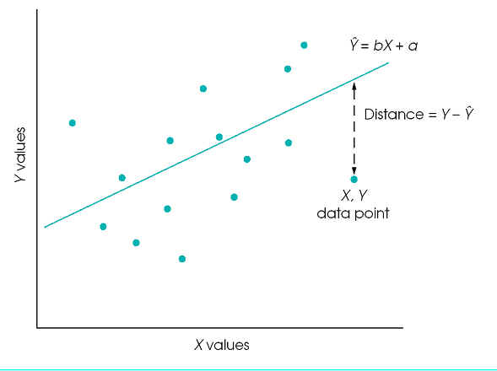

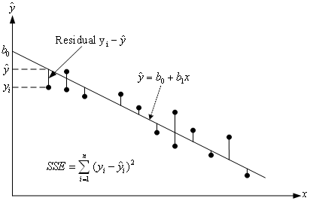

In the figure above, note that instead of a and b the parameters are called b₀ and b₁.

So we have our criterion for 'best fit'. How do we estimate a and b? It turns out that we can use calculus to find the values of a and b that minimize $\sum{(y−\hat{y})^{2}}$. When we do so, we discover the following:
$$b=r\frac{s_{y}}{s_{x}}$$

where r is the Pearson correlation coefficient (which we calculated in the preceding lecture). Once we know b, we can find a:

$$a=\overline{y}−b\overline{x}$$
where $\overline{x}$ and $\overline{y}$ are the means of x and y, respectively.

Prediction

We now have our linear regression equation. One thing we can do with it is to predict the y value for some new value of x. For instance, in our original example, the predicated amount of drilling error for a machine after 40 hours of use is:

$$\hat{y}=b×\text{40}+a$$

where a and b are the estimated regression equation coefficients.

3. Linear Regression with JMP

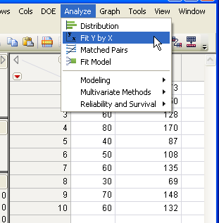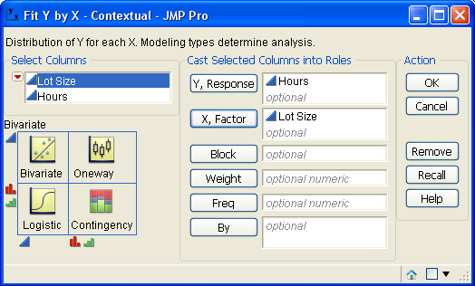

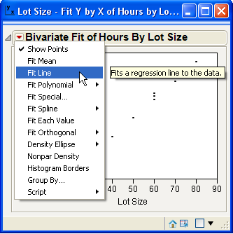 | 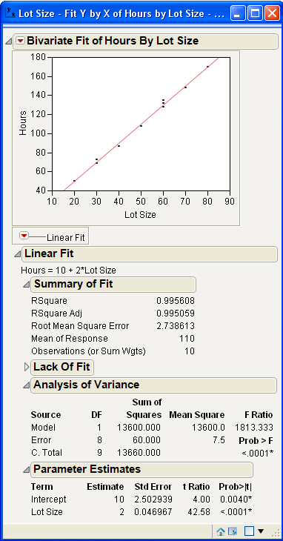

The results are in the Parameter Estimates area:

a = Intercept
b = name of variable (e.g., lot size)

Homework

1. Calculate the Pearson r for X and Y. Supply all values indicated. Use of Excel encouraged.

X | Y | z_{x} | z_{y} | z_{x} × z_{y}
1 | 5 | ? | ? | ?
2 | 2 | ? | ? | ?
4 | 4 | ? | ? | ?
5 | 1 | ? | ? | ?

$\overline{X}$= ?
$\overline{Y}$ = ?
s_{x} = ?
s_{y} = ?
n = ?
∑(z_{x} z_{y}) = ?
Pearson r = ?

2. What is the slope of the regression equation predicting Y from X?

3. If X is 6, what is the predicted value of Y? (Show formula and answer.)

Note, to check your answer, you can use the Excel pearson function:
= pearson(<x data range>, <y data range>)

Video (optional): http://www.youtube.com/watch?v=xIDjj6ZyFuw (first 3 minutes only)

